**Q3.Explain the use of grid-auto-row and grid-auto-column using code examples.**

grid-auto-row and grid-auto-column is similar to the grid-template-row and grid-template-column but there is some slight change between them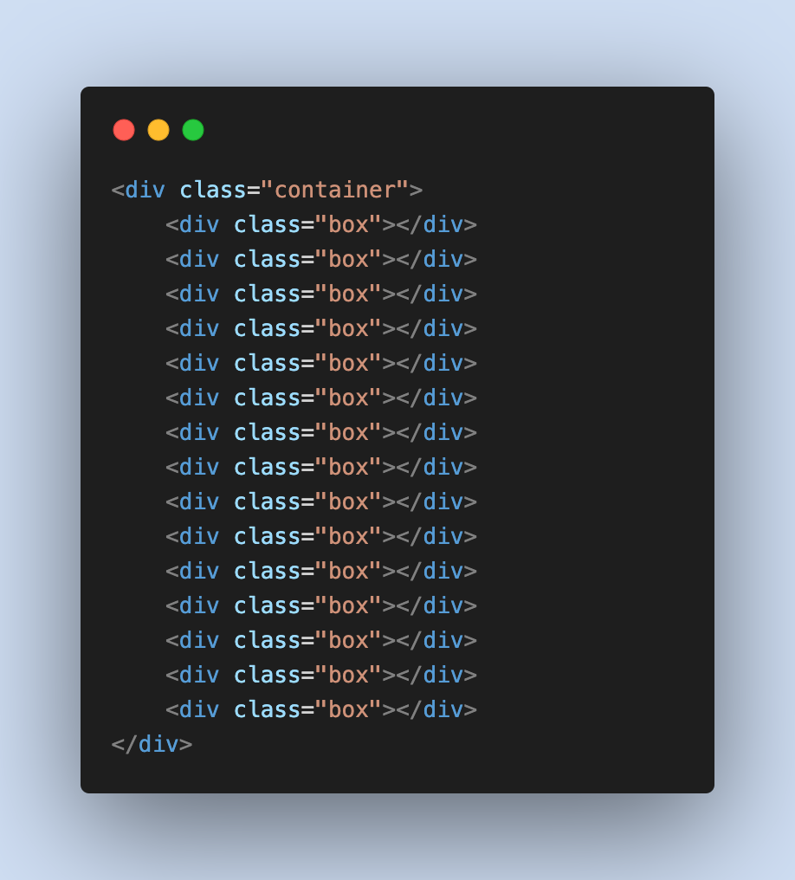

Here we consider some of the grid items and some css applied to it as shown in below figure.

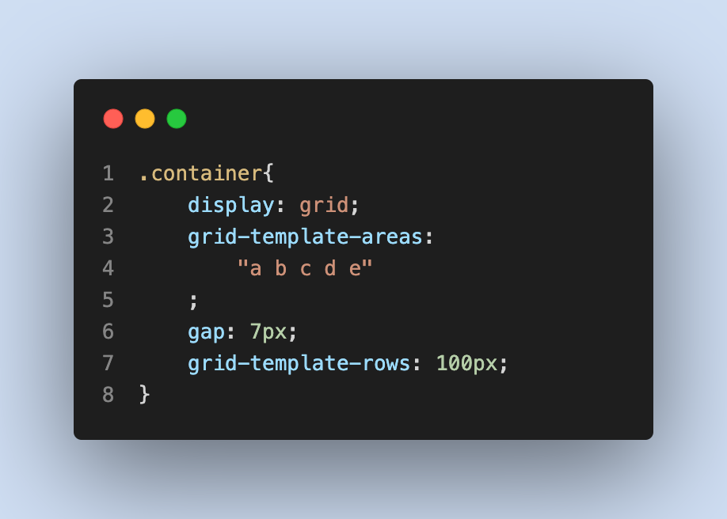

And it looks like this.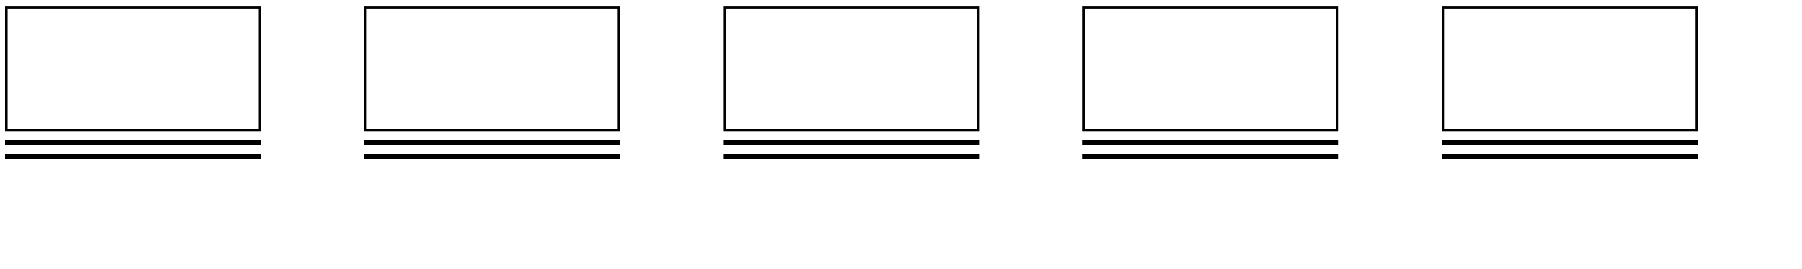

Here if we observe the css code we have explicitly mentioned the row value for the first-row explicitly, for other rows we have not mentioned it takes the default value as 0, which is just showing like a flat line. In order to avoid this thing we can use **grid-auto-rows.**

Below illustration shows about **grid-auto-rows.**

Here we have mentioned **grid-auto-rows** as **200px** this means the default value of row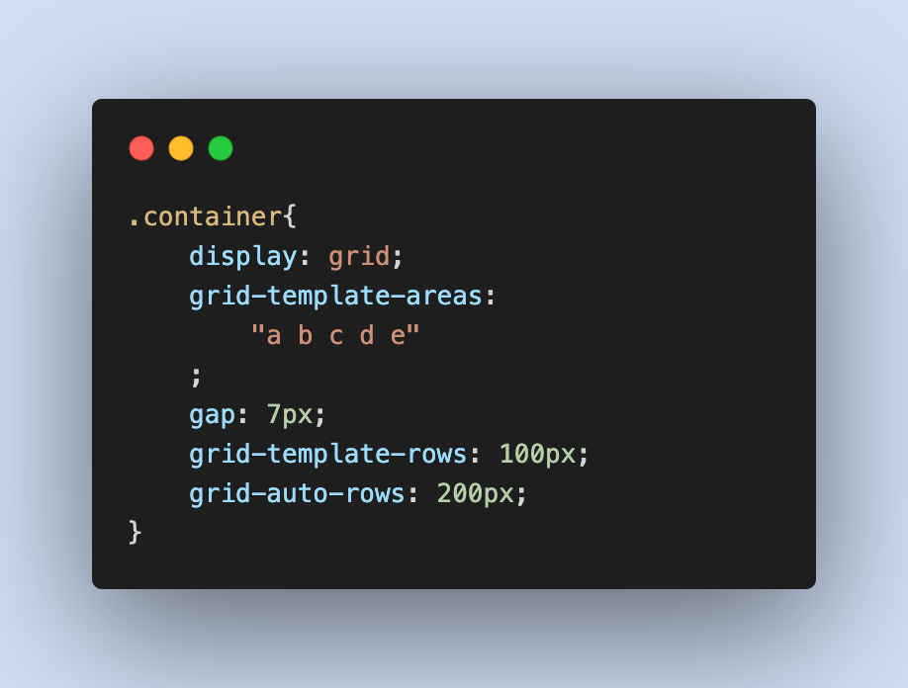 in a grid is **200px** we can change the default value for specific row also.

Similarly **grid-auto-column** also works as **grid-auto-row**.